Figure 7.1 RP Model Significant Variables

Figure 7.2 BE Model Significant Variables

Figure 7.3a SVM Model Significant Variables (1-12)

Figure 7.3b SVM Model Significant Variables (13-24)

Figure 7.3c SVM Model Significant Variables (25-36)

Figure 7.3d SVM Model Significant Variables (37-52)

Figure 7.3e SVM Model Significant Variables (53-67)



Figure 7.4 LR Model Significant Variables

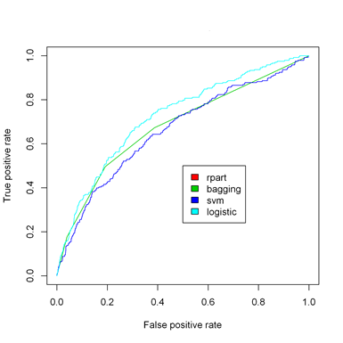

Figure 7.5 ROC Curve of Classification Models

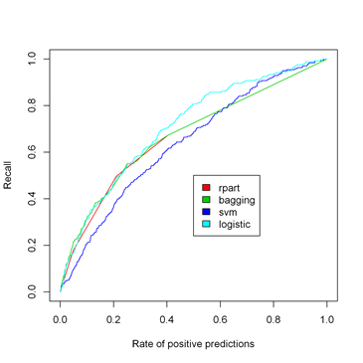

Figure 7.6 Cumulative Recall Curve of Classification Models

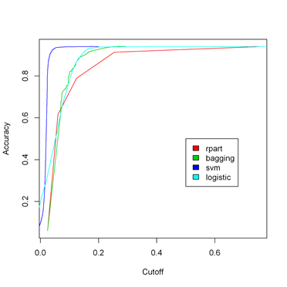

Figure 7.7 Accuracy versus Cut-off Curve of Classification Models